**Appendix S4**

Size-frequency distributions of A. amphisbaenians, B. lizards, and C. snakes

Data are from Appendix 1

A - Amphisbaenia

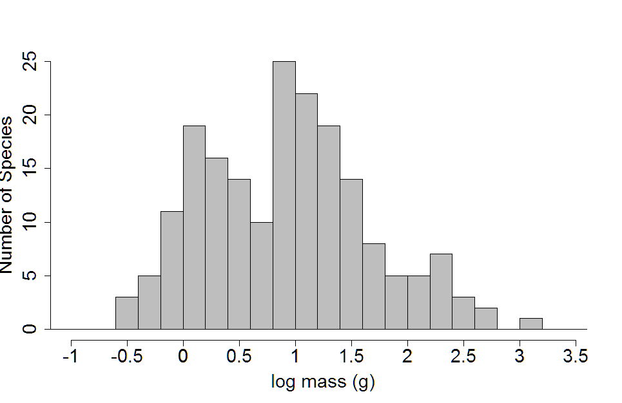

B - Sauria

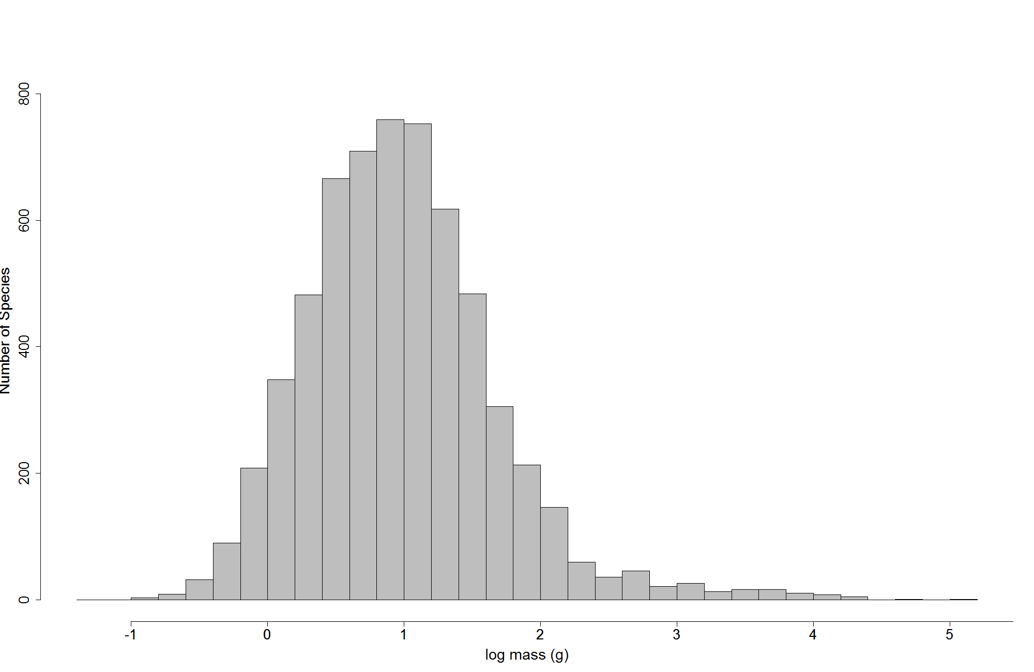

C - Serpentes

